中国石油地理信息系统（A4）

**A4数据库RAC集群+ArcSDE部署手册**

**中国石油地理信息系统（A4）项目组**

**2014年1月**

一、软件清单

|  |  |  |
| --- | --- | --- |
| 分类 | 名称 | 版本 |
| 操作系统 | Oracle Enterprise linux | 6.4 |
| ISCSI | iscsi-initiator-utils-6.2.0.873-2.0.1.el6.x86_64.rpm | 6.2.0.873 |
| ASM | oracleasm-support-2.1.8-1.el6.x86_64.rpm | 2.1.8-1 |
| Clusterware | p10404530_112030_Linux-x86-64_3of7.zip | 11.2.0.3 |
| 数据库软件 | cvuqdisk-1.0.9-1.rpm | 1.0.9-1 |
| Oracle11G | 11.2.0.3 |
| ArcGIS软件 | Desktop | 10.2 |
| ArcSDE | 10.2 |

二、Oracle RAC集群注意事项：

|  |
| --- |
| 1、集群中各个节点的时间应尽量一致 |
|  |
| 2、公共网络必须使用各个节点的同一个网卡 |
|  |
| 3、每个节点需要一个VIP，VIP必须和公共网络在一个子网中 |
|  |
| 4、在有些系统中（如Solaris），需要给VIP指定默认网关 |
|  |
| 5、对硬盘分区时，要保证在所有节点上都能看到分区信息 |
|  |
| 6、要为OCR设备和vote设备指定正确的权限和属主 |
|  |
| 7、要为公共IP、私有IP和VIP指定主机名，主机名中不能包含大写字母和_，但是可以包含减号（-） |
|  |
| 8、如果配置失败，应该把刚才的配置结果全部删除，从头再来 |
|  |
| 9、在安装clusterware时，需要设置环境变量ORACLE_HOME。在安装Oracle和RAC时，需要重新指定这个变量，而且不能指定同一个目录 |
|  |
| 10、正确配置节点间的信任关系 |

三、安装准备：

## 3.1.节点、网络、Oracle软件组件、存储组件清单：

|  |  |  |  |  |  |
| --- | --- | --- | --- | --- | --- |
| **节点** | | | | | |
| **节点名称** | **实例名称** | **数据库名称** | **处理器** | **RAM** | **操作系统** |
| **a4rac1** | a4rac1 | a4rac | 4vCPU | 5GB | OEL 6.4 - (x86_64) |
| **a4rac2** | a4rac2 | 4vCPU | 5GB | OEL 6.4 - (x86_64) |
| **FreeNAS1** |  |  | 2vCPU | 4GB | FreeNAS-8.3.0-RELEASE-p1-x64 |
| **网络配置** | | | | | |
| **节点名称** | **公共 IP 地址** | **心跳 IP 地址** | **虚拟 IP 地址** | **SCAN 名称** | **SCAN IP 地址** |
| **a4rac1** | 192.168.9.101 | 10.0.0.1 | 192.168.9.103 | a4rac.rac.cn | 192.168.9.105 |
| **a4rac2** | 192.168.9.102 | 10.0.0.2 | 192.168.9.104 |
| **FreeNAS1** | 192.168.9.100 |  |  |
| **Oracle 软件组件** | | | | | |
| **软件组件** | **操作系统用户** | **主组** | **辅助组** | **主目录** | **Oracle 基目录/Oracle 主目录** |
| **Grid Infrastructure** | grid | oinstall | dba | /home/grid | /u01/app/grid  /u01/app/gridbase |
| **Oracle RAC** | oracle | oinstall | dba | /home/oracle | /u01/app/oraclebase /u01/app/oracle/product/11203/db |
| **存储组件** | | | | | |
| **存储组件** | **文件系统** | **分区大小** | **ASM 卷组名** | **ASM 冗余** | **FreeNAS iscsi目标名** |
| **OCR/表决磁盘** | ASM | 20GB | +CRS | External | target-rac-20131227 |
| **数据库文件** | ASM | 60GB | +RACDB_DATA | Normal | target-rac-20131227 |
| **快速恢复区** | ASM | 20GB | +FRA | External | target-rac-20131227 |

## 3.2.配置公共网络和专用网络：

分别在RAC节点1、2上做如下规划配置：

|  |  |  |  |  |
| --- | --- | --- | --- | --- |
| Oracle RAC 节点 1 — (a4rac1) | | | | |
| **设备** | **IP 地址** | **子网** | **网关** | **用途** |
| eth0 | 192.168.1.101 | 255.255.255.0 | 192.168.1.254 | 将 a4rac1连接到公共网络 |
| eth1 | 10.0.0.1 | 255.255.255.0 |  | 将a4rac1（互连）连接到a4rac2 (a4rac2-pri) |
| **/etc/hosts**  #修改hosts文件 | | | | |
| 127.0.0.1 localhost localhost.localdomain localhost4 localhost4.localdomain4  ::1 localhost localhost.localdomain localhost6 localhost6.localdomain6  192.168.9.101 a4rac1  10.0.0.1 a4rac1-pri  192.168.9.103 a4rac1-vip  192.168.9.102 a4rac2  10.0.0.2 a4rac2-pri  192.168.9.104 a4rac2-vip  #192.168.9.105 a4rac.rac.cn 在DNS服务器配置解析该域名 | | | | |
| /etc/resolv.conf #配置DNS | | | | |
| # Generated by NetworkManager  search rac.cn  nameserver 192.168.1.3 | | | | |
| /etc/sysconfig/network #修改主机名 | | | | |
| NETWORKING=yes  HOSTNAME=a4rac1  NOZEROCONF=yes | | | | |

|  |  |  |  |  |
| --- | --- | --- | --- | --- |
| Oracle RAC 节点 2 — (a4rac2) | | | | |
| **设备** | **IP 地址** | **子网** | **网关** | **用途** |
| eth0 | 192.168.1.102 | 255.255.255.0 | 192.168.1.254 | 将 a4rac2连接到公共网络 |
| eth1 | 10.0.0.2 | 255.255.255.0 |  | 将a4rac2（互连）连接到a4rac1 (a4rac1-pri) |
| **/etc/hosts #修改hosts文件** | | | | |
| 127.0.0.1 localhost localhost.localdomain localhost4 localhost4.localdomain4  ::1 localhost localhost.localdomain localhost6 localhost6.localdomain6  192.168.9.101 a4rac1  10.0.0.1 a4rac1-pri  192.168.9.103 a4rac1-vip  192.168.9.102 a4rac2  10.0.0.2 a4rac2-pri  192.168.9.104 a4rac2-vip  #192.168.9.105 a4rac.rac.cn 在DNS服务器配置解析该域名 | | | | |
| /etc/resolv.conf #配置DNS | | | | |
| # Generated by NetworkManager  search rac.cn  nameserver 192.168.1.3 | | | | |
| /etc/sysconfig/network #修改主机名 | | | | |
| NETWORKING=yes  HOSTNAME=a4rac2  NOZEROCONF=yes | | | | |

## 3.3.调整系统内核参数

以Root用户登录，在两个节点分别作如下配置：

vi /etc/sysctl.conf

fs.aio-max-nr = 1048576

fs.file-max = 6815744

kernel.shmmni = 4096

kernel.sem = 250 32000 100 128

net.ipv4.ip_local_port_range = 9000 65500

net.core.rmem_default = 262144

net.core.rmem_max = 4194304

net.core.wmem_default = 262144

net.core.wmem_max = 1048586

使内核参数生效：#/sbin/sysctl –p

vi /etc/security/limits.conf

grid soft nproc 2047

grid hard nproc 16384

grid soft nofile 1024

grid hard nofile 65536

oracle soft nproc 2047

oracle hard nproc 16384

oracle soft nofile 1024

oracle hard nofile 65536

## 3.4 存储划分和配置

分别在RAC1、2节点上安装ISCSI软件：

rpm -ivh iscsi-initiator-utils-6.2.0.873-2.0.1.el6.x86_64.rpm

设置开机自动启动iSCSI服务器：

chkconfig iscsi on

发现存储目标：

iscsiadm -m discovery -t sendtargets -p 192.168.9.100:3260

登录挂载存储目标：

iscsiadm -m node -T iqn.2011-03.example.org.istgt:target-rac-20131227 -p 192.168.9.100 -l

查看挂载的存储目标：

fdisk -l

Disk /dev/sdb: 107.4 GB, 107374181888 bytes

255 heads, 63 sectors/track, 13054 cylinders

Units = cylinders of 16065 * 512 = 8225280 bytes

Sector size (logical/physical): 512 bytes / 512 bytes

I/O size (minimum/optimal): 4096 bytes / 1048576 bytes

Disk identifier: 0x00000000

对存储目标进行分区：

fdisk /dev/sdb #只在节点1上执行分区即可

修改存储分区权限：

chown grid:oinstall /dev/sdb1

chown grid:oinstall /dev/sdb2

chown grid:oinstall /dev/sdb3

chown grid:oinstall /dev/sdb4

chmod 666 /dev/sdb1

chmod 666 /dev/sdb2

chmod 666 /dev/sdb3

chmod 666 /dev/sdb4

编辑/etc/rc.d/rc.local，添加如下内容：

chown grid:oinstall /dev/sdb1

chown grid:oinstall /dev/sdb2

chown grid:oinstall /dev/sdb3

chown grid:oinstall /dev/sdb4

chmod 666 /dev/sdb1

chmod 666 /dev/sdb2

chmod 666 /dev/sdb3

chmod 666 /dev/sdb4

## 3.5 创建Grid、Oracle用户及安装目录

以root用户登录，做如下配置：

/usr/sbin/groupadd -g 1000 oinstall

/usr/sbin/groupadd -g 1001 dba

/usr/sbin/useradd -u 501 -g oinstall -G dba grid

/usr/sbin/useradd -u 502 -g oinstall -G dba oracle

mkdir /u01

chown -R grid:oinstall /u01

mkdir -p /u01/app/oracle/product/11203/db

mkdir -p /u01/app/gridbase

mkdir -p /u01/app/oraclebase

chown -R grid:oinstall /u01/app/gridbase

chown -R oracle:oinstall /u01/app/oraclebase

mkdir /u01/app/grid

chmod 744 /u01

chown -R grid:oinstall /u01/app/oracle

chown -R grid:oinstall /u01/app/grid

chown -R oracle:oinstall //u01/app/oracle/product/11203/db

在两台主机检测是否存在nobody用户，若没有须创建nobody用户

## 3.6 为Oracle用户配置环境变量

节点a4rac1 grid用户家目录下修改.bash_profile文件：

export ORACLE_SID=+ASM1

export ORACLE_BASE=/u01/app/gridbase

export ORACLE_HOME=/u01/app/grid

PATH=$PATH:$HOME/bin:$ORACLE_HOME/bin

节点a4rac1 oracle用户家目录下修改.bash_profile文件：

export ORACLE_SID=a4rac1

export ORACLE_BASE=/u01/app/oraclebase

export ORACLE_HOME=/u01/app/oracle/product/11203/db

PATH=$PATH:$HOME/bin:$ORACLE_HOME/bin

节点a4rac2 grid用户家目录下修改.bash_profile文件：

export ORACLE_SID=+ASM2

export ORACLE_BASE=/u01/app/gridbase

export ORACLE_HOME=/u01/app/grid

PATH=$PATH:$HOME/bin:$ORACLE_HOME/bin

节点a4rac2 oracle用户家目录下修改.bash_profile文件：

export ORACLE_SID=a4rac2

export ORACLE_BASE=/u01/app/oraclebase

export ORACLE_HOME=/u01/app/oracle/product/11203/db

PATH=$PATH:$HOME/bin:$ORACLE_HOME/bin

修改完后，分别Oracle和grid用户下执行：

source .bash_profile #重新加载配置文件

## 3.7 配置等效性

在两台主机做如下设置：

$cd $HOME

$vi .rhosts

输入+

## 3.8 配置节点之间ssh互信

用grid和oracle用户分别登录，做如下配置：

mkdir ~/.ssh

chmod 700 ~/.ssh

/usr/bin/ssh-keygen –t rsa

/usr/bin/ssh-keygen –t dsa

touch ~/.ssh/authorized_keys

cat ~/.ssh/id_rsa.pub >> ~/.ssh/authorized_keys

cat ~/.ssh/id_dsa.pub >> ~/.ssh/authorized_keys

下面两个节点建立信任关系：

exec /usr/bin/ssh-agent $SHELL

/usr/bin/ssh-add

[oracle@a4rac1 ~]$ ssh a4rac2 cat .ssh/id_rsa.pub >> .ssh/authorized_keys

oracle@a4rac2's password:

[oracle@a4rac1 ~]$ ssh a4rac2 cat .ssh/id_dsa.pub >> .ssh/authorized_keys

oracle@a4rac2's password:

[oracle@a4rac1 ~]$ scp .ssh/authorized_keys a4rac2:~./ssh

确认ForwardX11置为no

编辑或创建$ vi ~/.ssh/config

内容如下：HOST *

ForwardX11 no

## 3.9配置hangcheck-timer 内核模块

该模块的配置是可选的，但Oracle 建议你配置该模块。

以root 用户身份执行，在所有节点上做如下配置。

查看模块是否存在

# find /lib/modules -name "hangcheck-timer.ko"

编辑/etc/modprobe.conf

# vi /etc/modprobe.conf

在文件的末尾加入一行

options hangcheck-timer hangcheck_tick=30 hangcheck_margin=180

配置为自启动

vi /etc/rc.d/rc.local

在文件的末尾加入一行

/sbin/modprobe hangcheck_timer

启动hangcheck

# modprobe hangcheck_timer

检查hangcheck 是否成功启动

# grep hangcheck /var/log/messages | tail -2

如果显示下述信息说明已经成功启动hangcheck

Mar 16 12:52:32 node2 kernel: Hangcheck: starting hangcheck timer 0.5.0 (tick

is 180 seconds, margin is 60 seconds).

## 3.10.安装Oracleasm软件：

分别在a4rac1、a4rac2上安装：

#oracleasm软件在Oracle enterprise linux 6.4安装包中自带有。

[root@a4rac1 software]# rpm -ivh oracleasm-support-2.1.8-1.el6.x86_64.rpm

warning: oracleasm-support-2.1.8-1.el6.x86_64.rpm: Header V3 RSA/SHA256 Signature, key ID ec551f03: NOKEY

Preparing... ########################################### [100%]

1:oracleasm-support ########################################### [100%]

[root@a4rac2 software]# rpm -ivh oracleasm-support-2.1.8-1.el6.x86_64.rpm

warning: oracleasm-support-2.1.8-1.el6.x86_64.rpm: Header V3 RSA/SHA256 Signature, key ID ec551f03: NOKEY

Preparing... ########################################### [100%]

1:oracleasm-support ########################################### [100%]

#配置oracleasm，user输入oracle，group输入dba，其余默认回车即可。

[root@a4rac1 ~]# service oracleasm configure

Configuring the Oracle ASM library driver.

This will configure the on-boot properties of the Oracle ASM library

driver. The following questions will determine whether the driver is

loaded on boot and what permissions it will have. The current values

will be shown in brackets ('[]'). Hitting <ENTER> without typing an

answer will keep that current value. Ctrl-C will abort.

Default user to own the driver interface []: oracle

Default group to own the driver interface []: dba

Start Oracle ASM library driver on boot (y/n) [n]: y

Scan for Oracle ASM disks on boot (y/n) [y]:

Writing Oracle ASM library driver configuration: done

Initializing the Oracle ASMLib driver: [ OK ]

Scanning the system for Oracle ASMLib disks: [ OK ]

分别在1、2节点上配置oracleasm：

[root@a4rac2 rpm]# /etc/init.d/oracleasm configure

Configuring the Oracle ASM library driver.

This will configure the on-boot properties of the Oracle ASM library

driver. The following questions will determine whether the driver is

loaded on boot and what permissions it will have. The current values

will be shown in brackets ('[]'). Hitting <ENTER> without typing an

answer will keep that current value. Ctrl-C will abort.

Default user to own the driver interface [oracle]: grid

Default group to own the driver interface [dba]: dba

Start Oracle ASM library driver on boot (y/n) [y]: y

Scan for Oracle ASM disks on boot (y/n) [y]: y

Writing Oracle ASM library driver configuration: done

Initializing the Oracle ASMLib driver: [ OK ]

Scanning the system for Oracle ASMLib disks: [ OK ]

# 四、安装grid：

运行安装程序:

su - grid

ls

grid grid1 p10404530_112030_Linux-x86-64_3of7.zip

cd grid

ls

doc install readme.html response rpm runcluvfy.sh runInstaller sshsetup stage welcome.html

./runInstaller

Starting Oracle Universal Installer...

Checking Temp space: must be greater than 120 MB. Actual 20069 MB Passed

Checking swap space: must be greater than 150 MB. Actual 9999 MB Passed

Checking monitor: must be configured to display at least 256 colors. Actual 16777216 Passed

Preparing to launch Oracle Universal Installer from /tmp/OraInstall2013-12-30_10-24-53PM. Please wait ...[grid@a4-rac1 grid]$

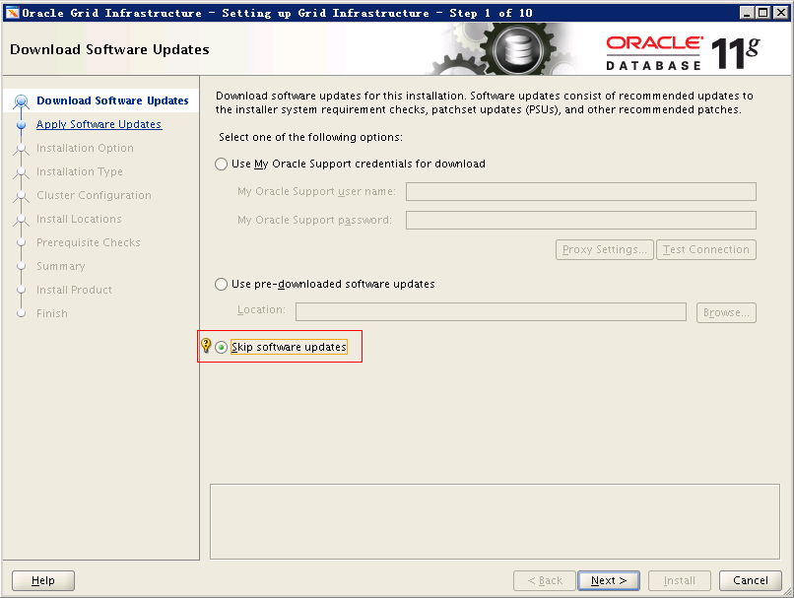

选择忽略更新。

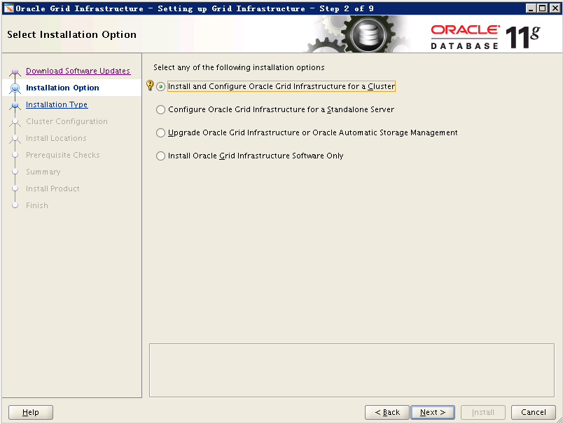

选择安装和配置Oracle Grid Infrastructure在集群环境中。

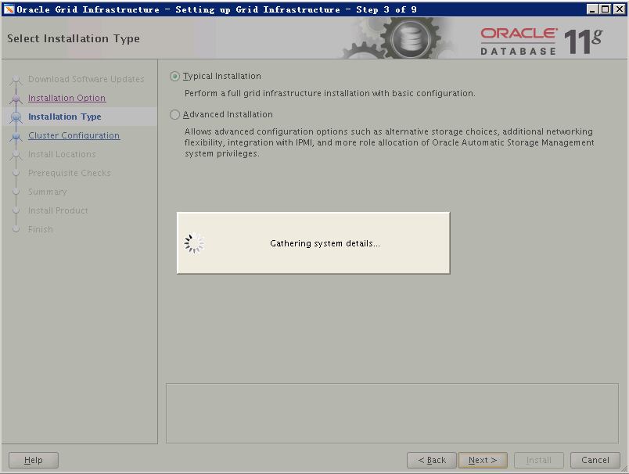

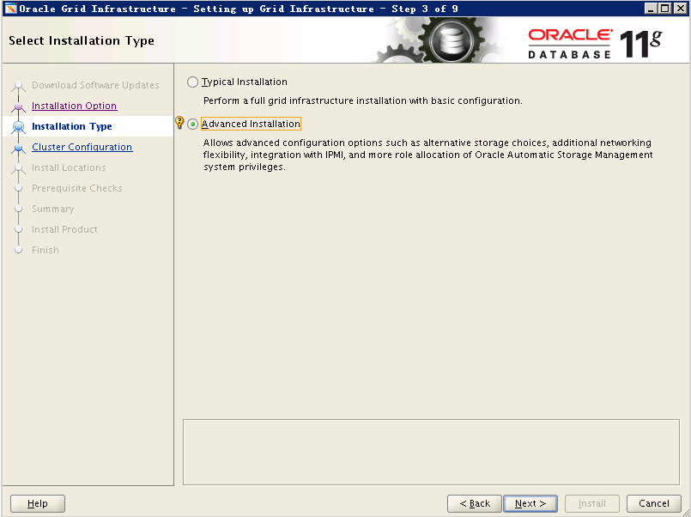

选择自定义安装。

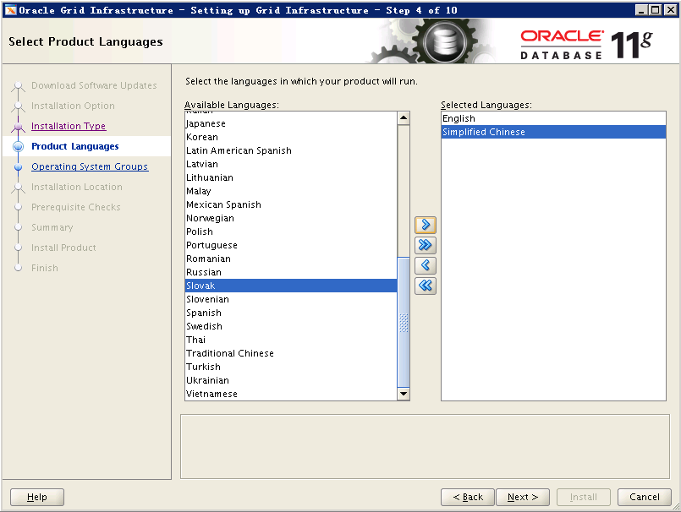

选择语言英语和简体中文。

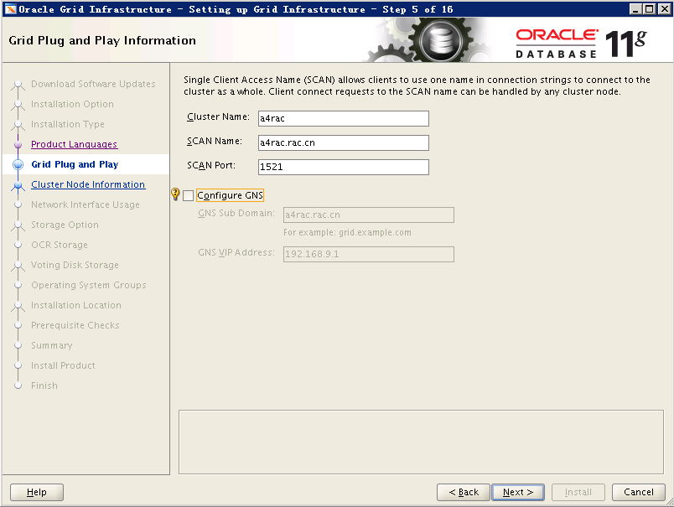

输入RAC集群公共实例名和SCAN Name（要和DNS或者hosts中的一致）及端口号。

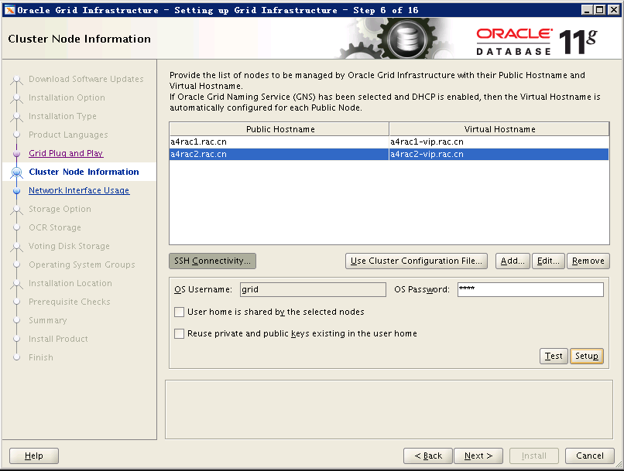

添加对应的主机名（和hosts文件对应一致）。

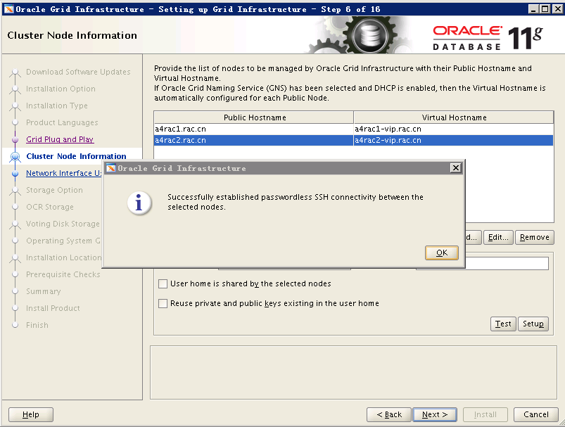

输入grid用户密码，点击“Setup”。

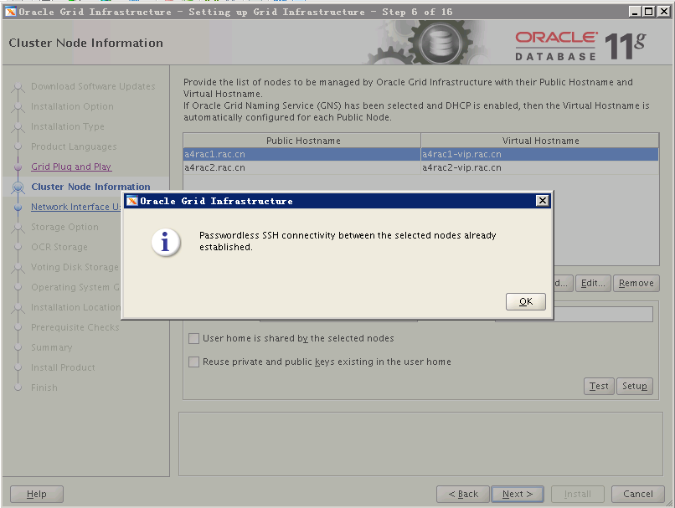

点击“Test”。

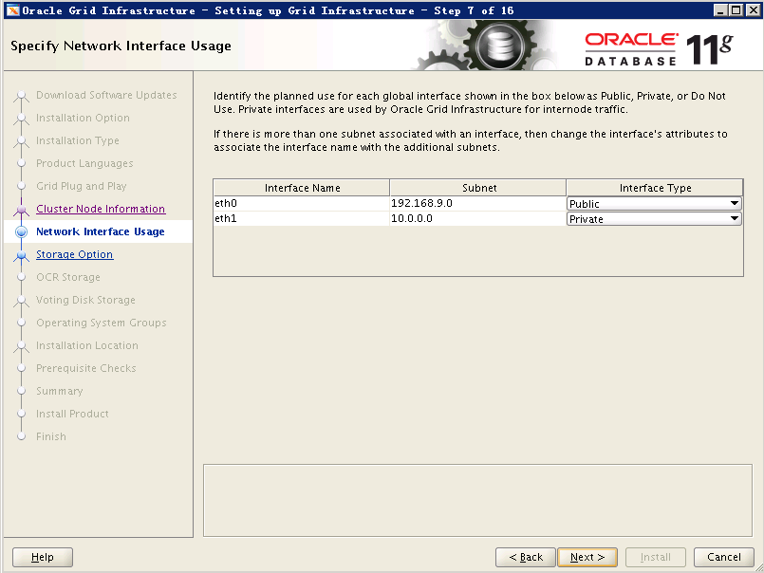

确定网络配置，点击“Next”。

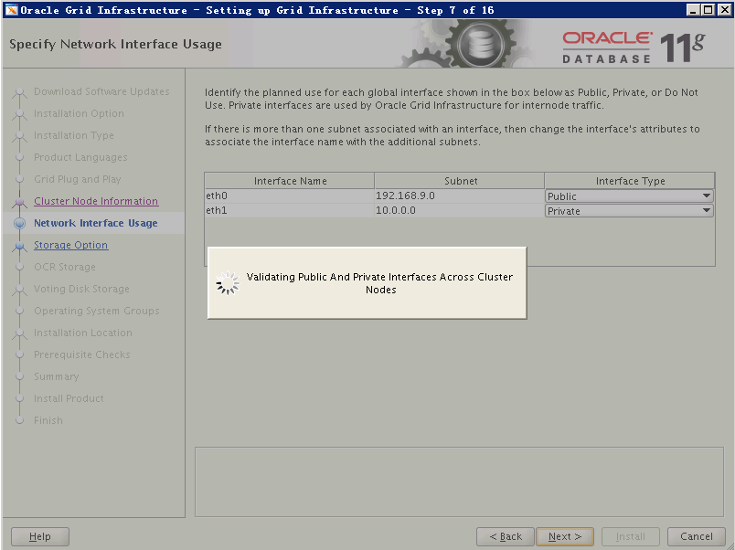

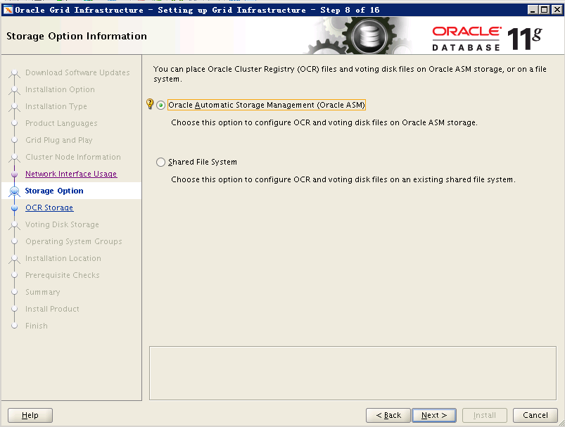

选择自动管理ASM。

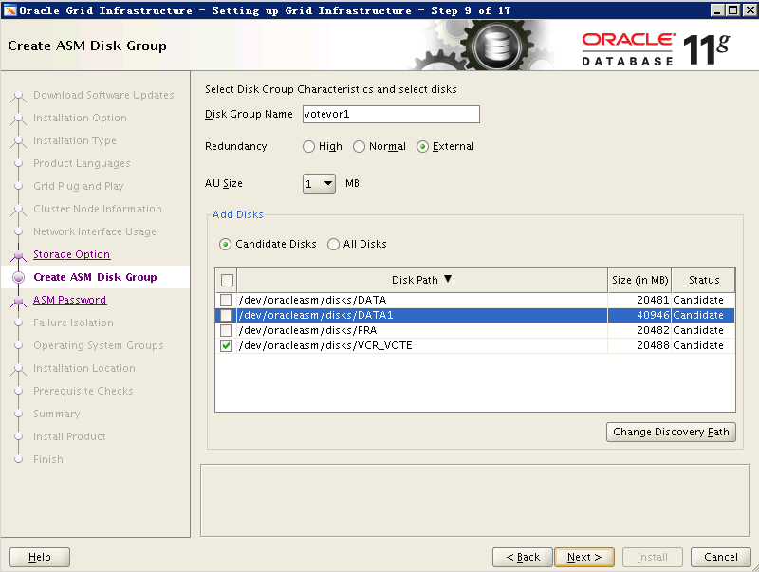

创建仲裁磁盘组。

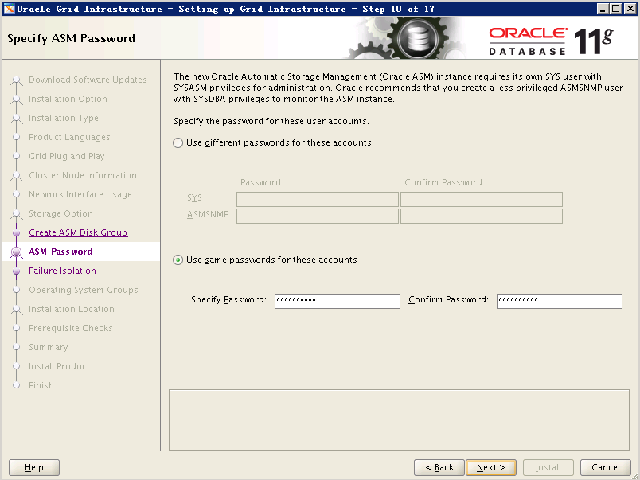

设置SYSASM仲裁磁盘组密码。

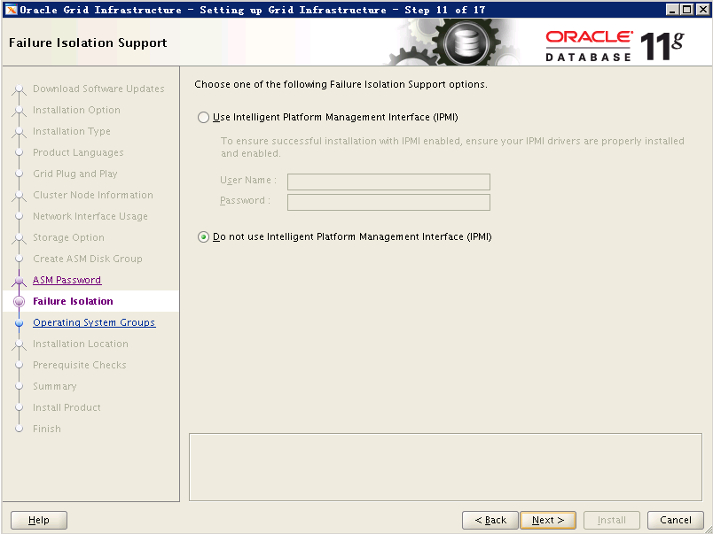

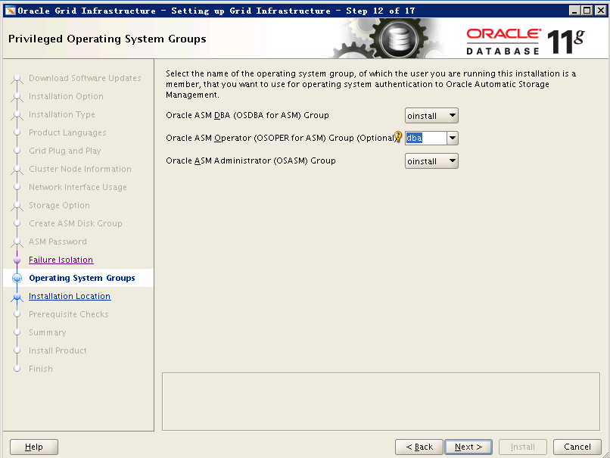

ASM Operator Group选择“dba”。

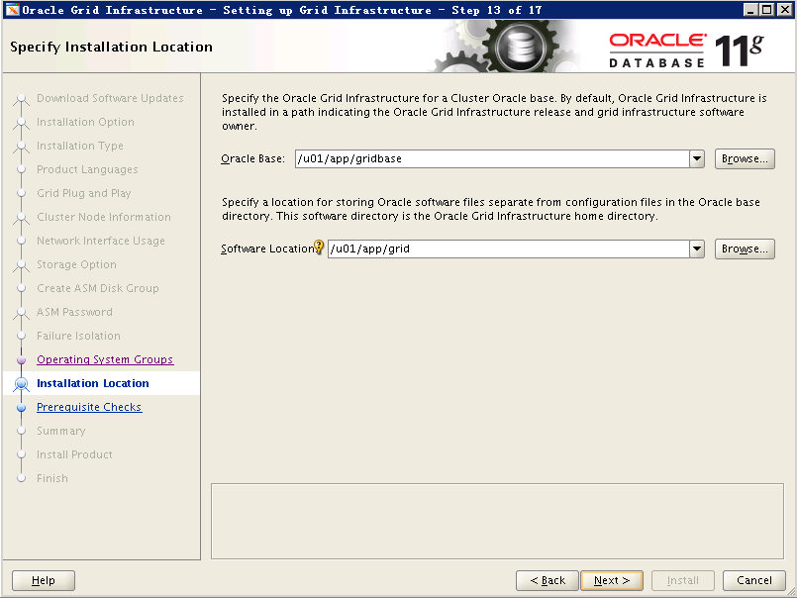

选择安装基目录（和hosts文件配置一致）。

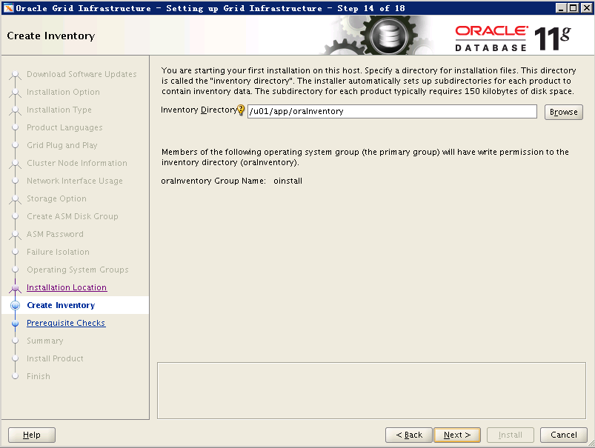

选择Inventory Directory（如果提示不存在则用一下命令创建并修改相应权限）：

mkdir -p /u01/app/oraInventory

chown -R grid:oinstall /u01/app/oraInventory

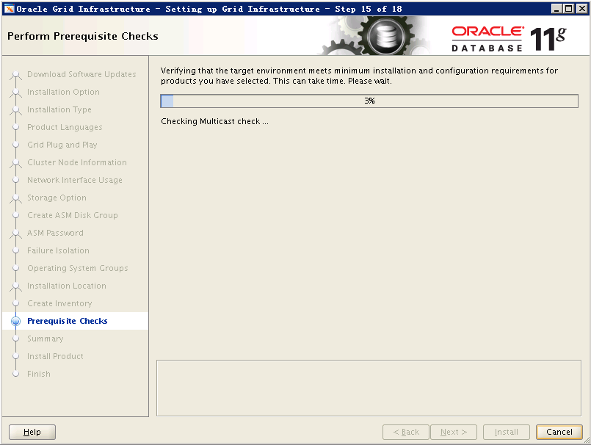

检查系统环境，安装提示没有安装的软件包。

[root@a4rac1 rpm]# rpm -ivh cvuqdisk-1.0.9-1.rpm

Preparing... ########################################### [100%]

Using default group oinstall to install package

1:cvuqdisk ########################################### [100%]

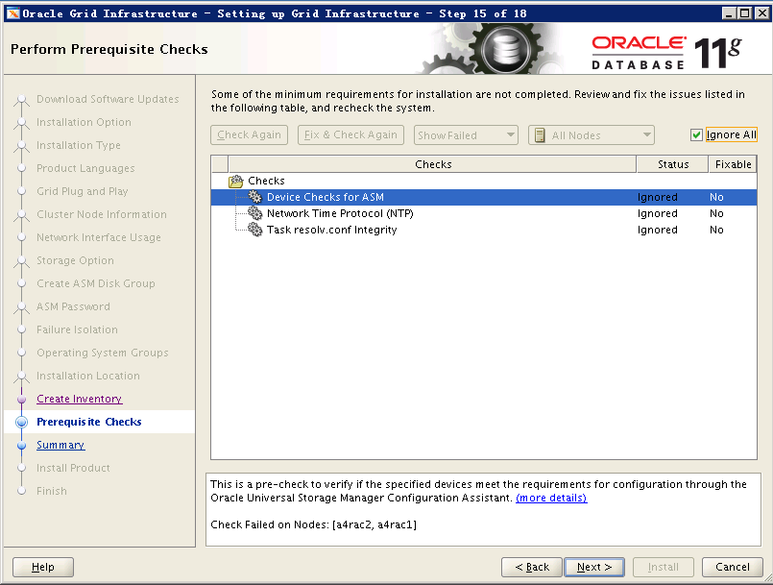

忽略点击“Next”。

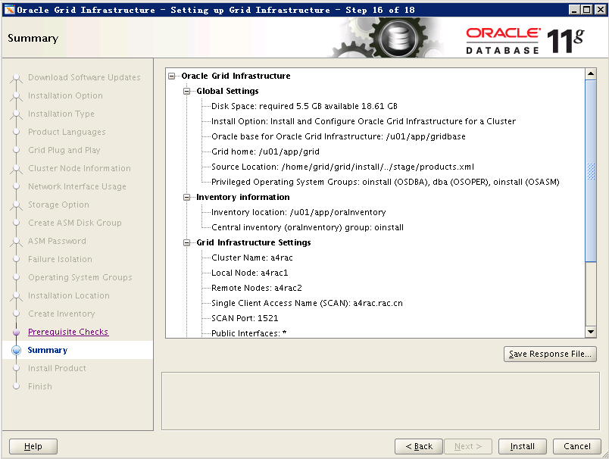

点击“Install”开始安装。

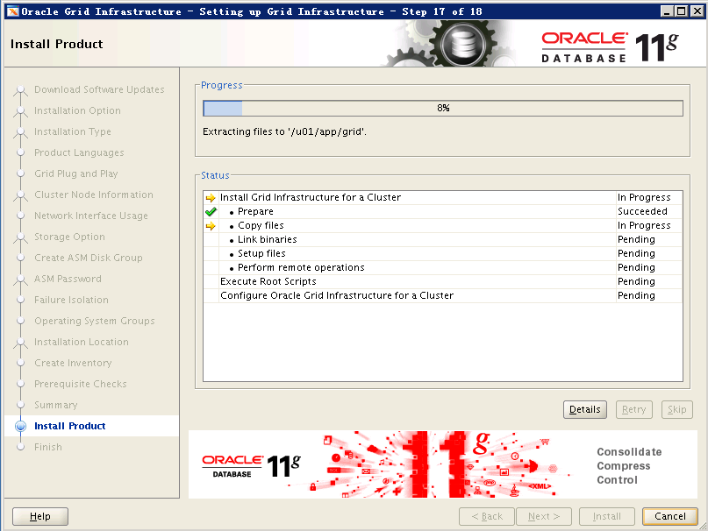

分别在RAC两个节点上行这两个脚本。

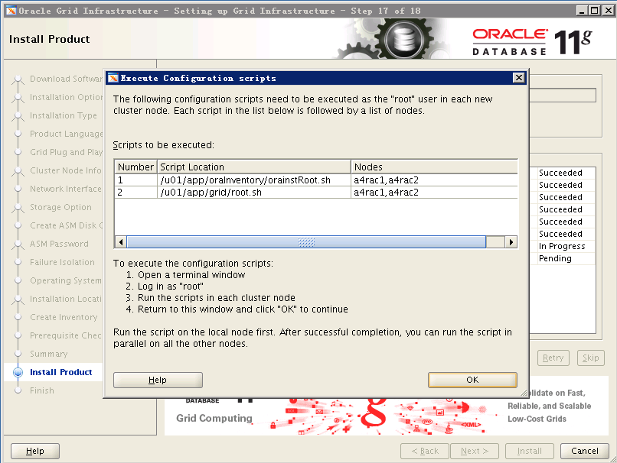

/u01/app/grid/crs/install/rootcrs.pl

/u01/app/grid/root.sh

检查CRS是否安装成功：

[root@a4rac1 ~]# su - grid

[grid@a4rac1 ~]$ olsnodes

a4rac1

a4rac2

[grid@a4rac1 ~]$ crsctl check crs

CRS-4638: Oracle High Availability Services is online

CRS-4537: Cluster Ready Services is online

CRS-4529: Cluster Synchronization Services is online

CRS-4533: Event Manager is online

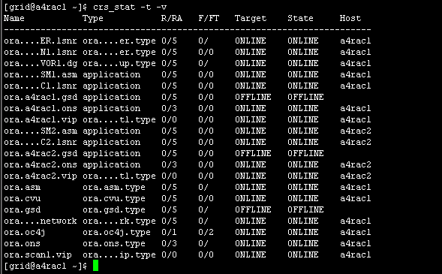

[grid@a4rac1 ~]$ srvctl status listener

Listener LISTENER is enabled

Listener LISTENER is running on node(s): a4rac1,a4rac2

# 五、安装数据库软件：

执行安装软件：

[oracle@a4rac1 database]$ ./runInstaller

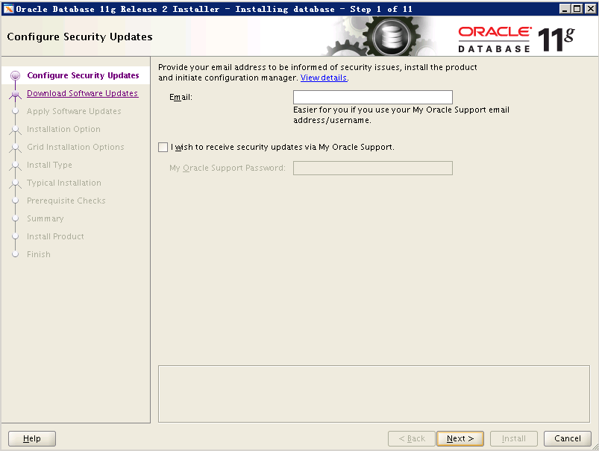

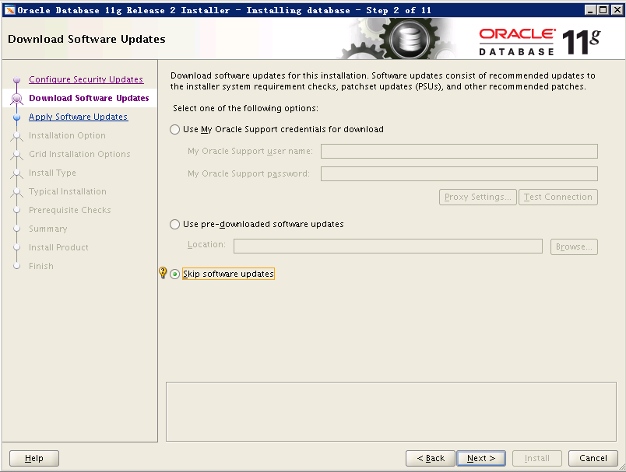

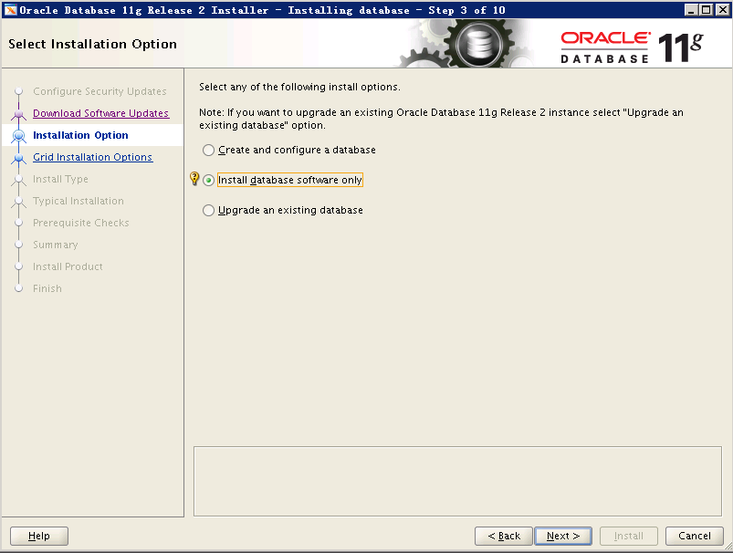

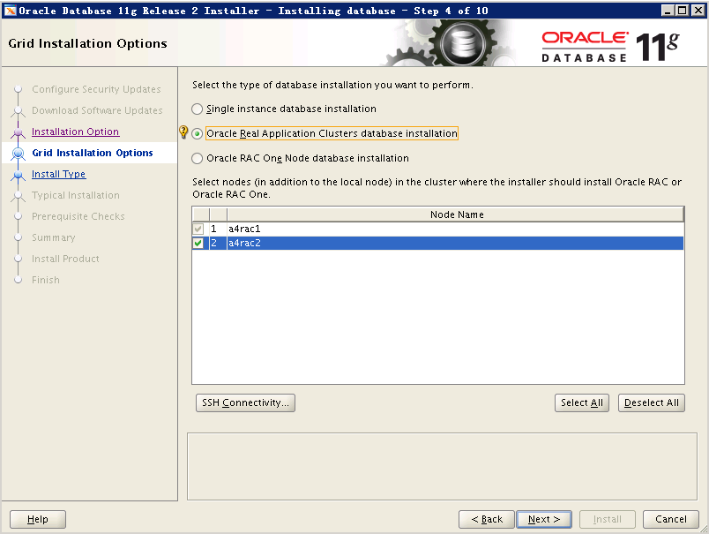

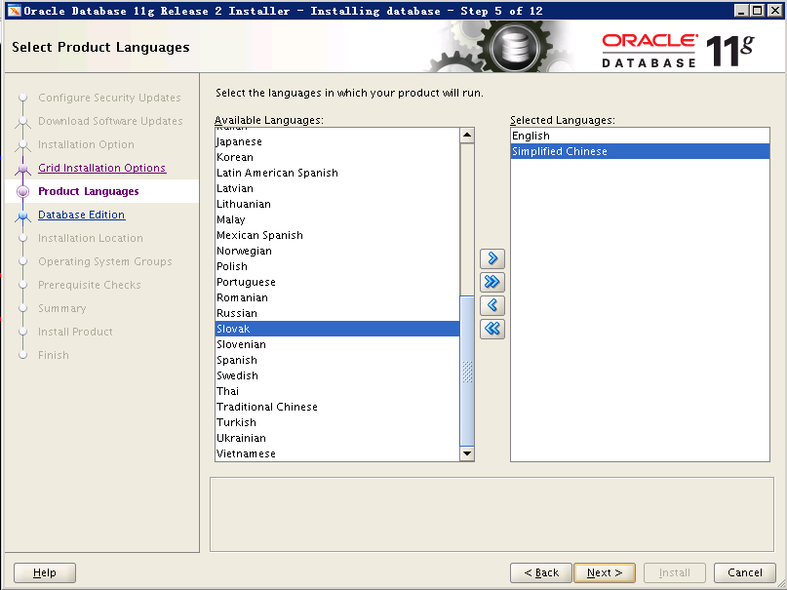

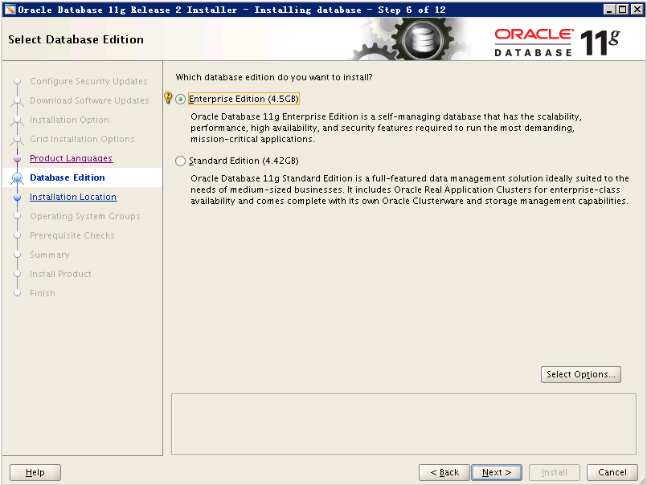

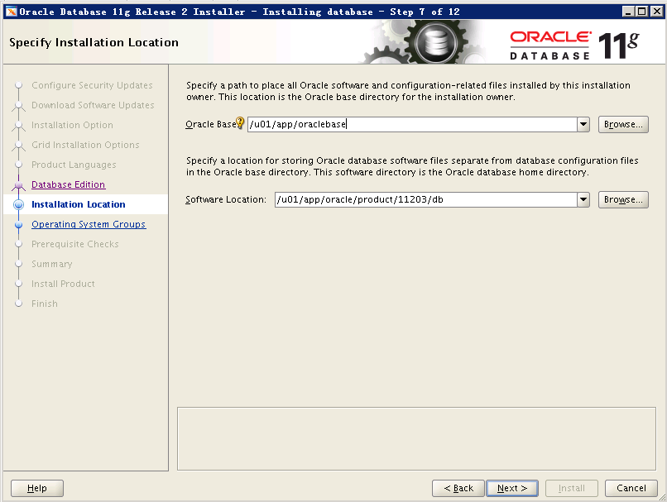

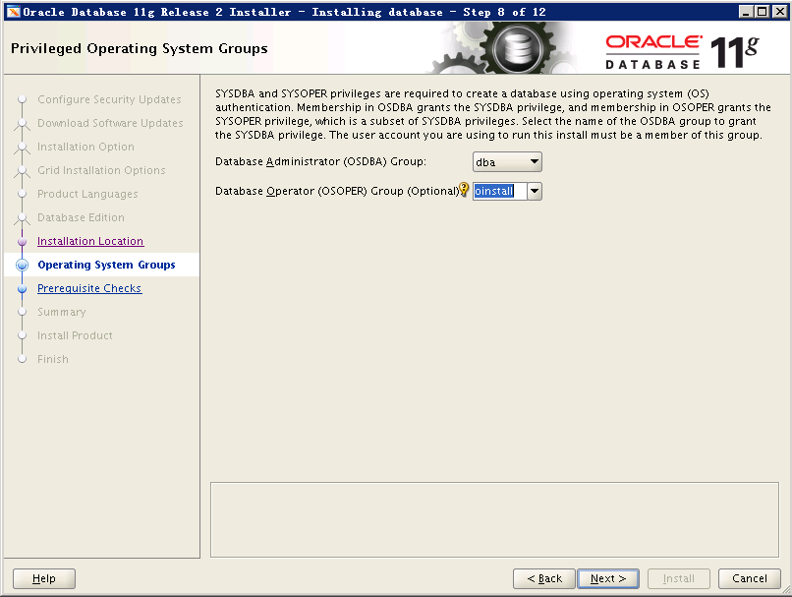

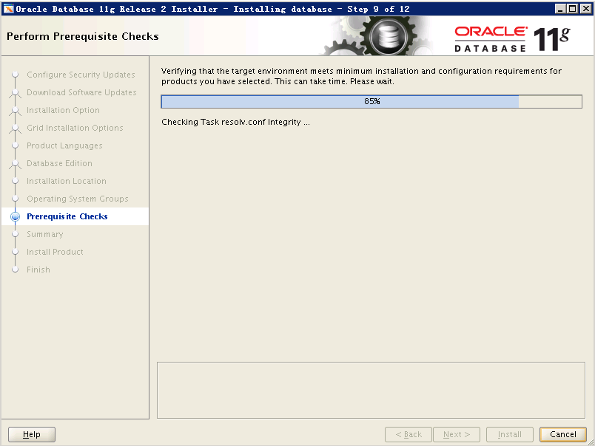

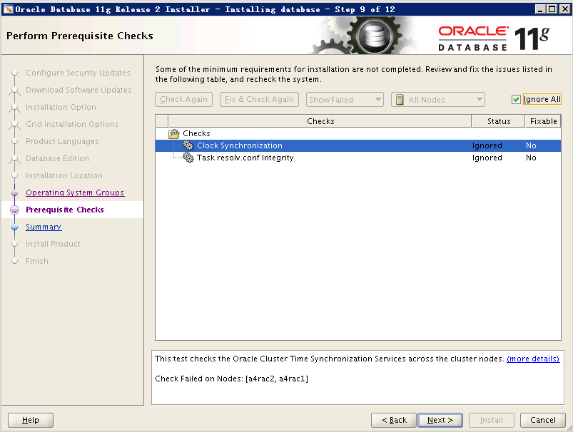

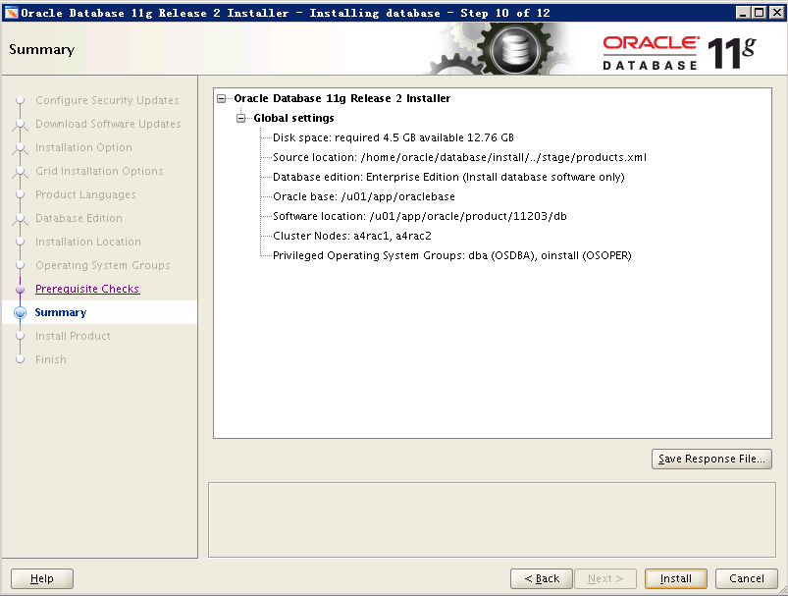

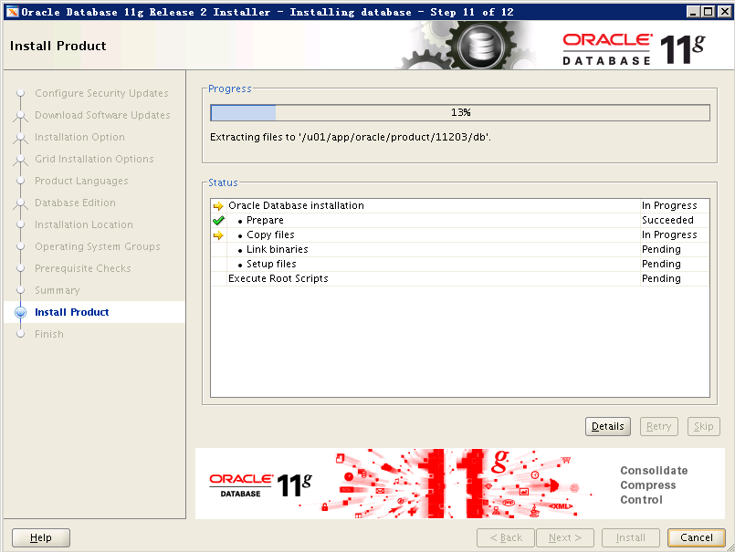

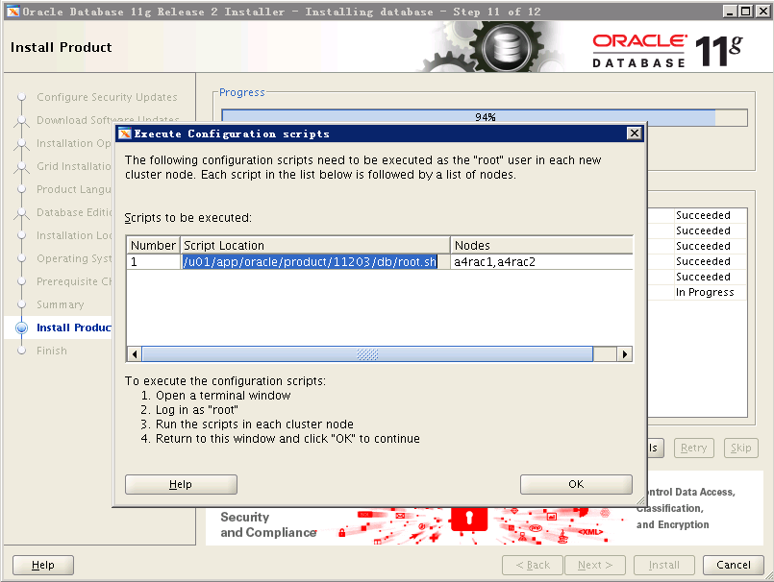

[root@a4rac1 ~]# /u01/app/oracle/product/11203/db/root.sh

[root@a4rac2 ~]# /u01/app/oracle/product/11203/db/root.sh

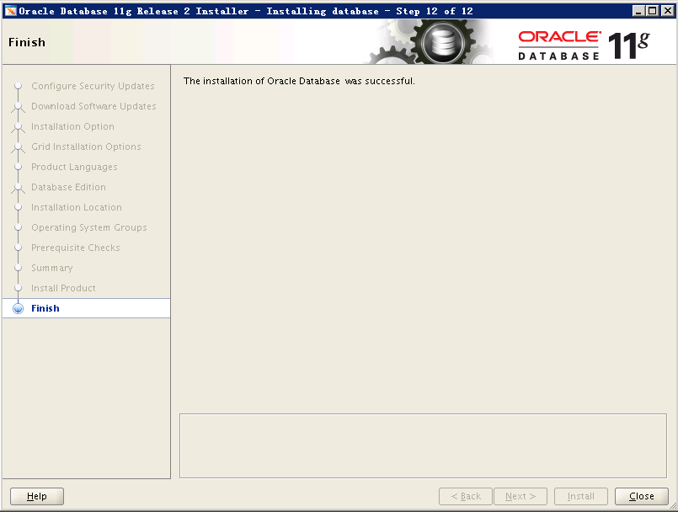

# 六、创建数据存放ASM盘：

[grid@a4rac1 ~]$ asmca

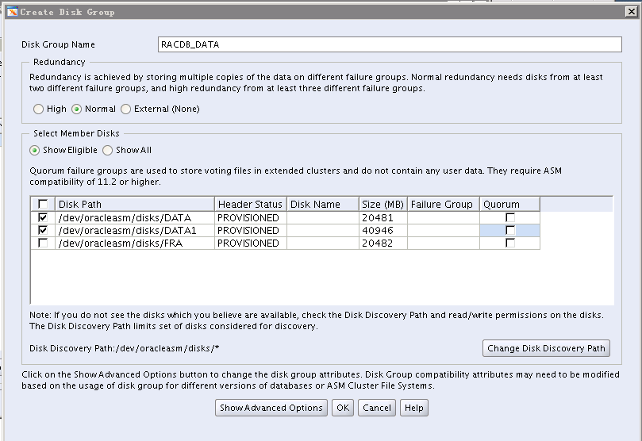

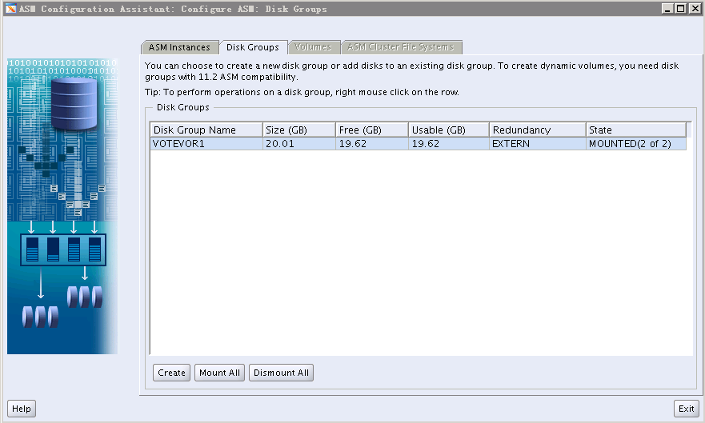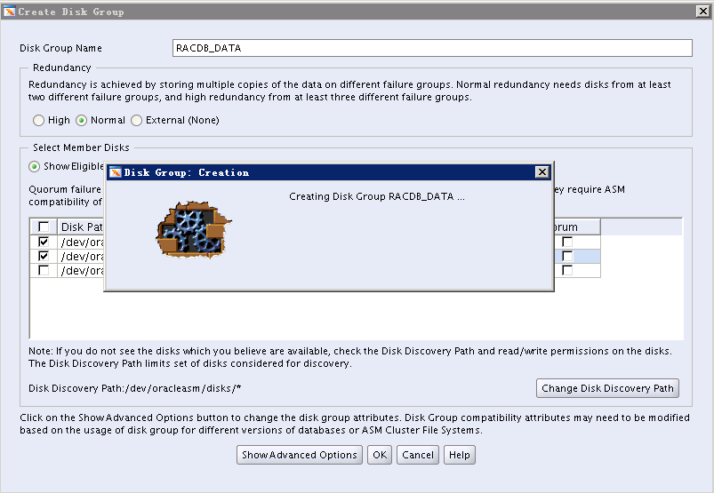

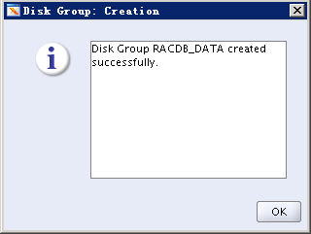

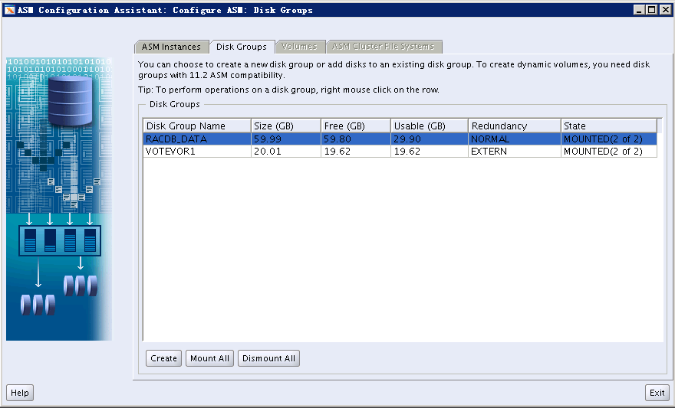

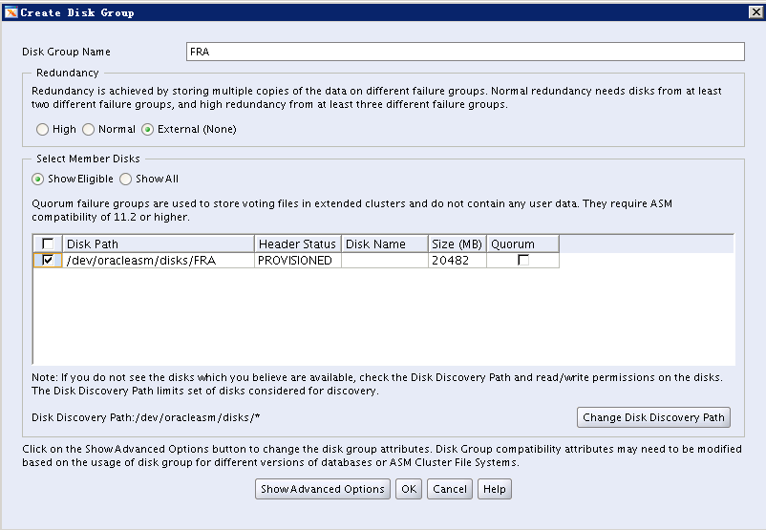

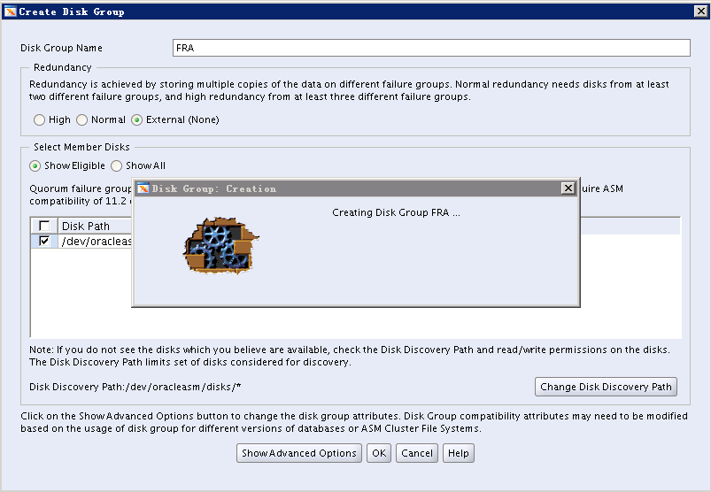

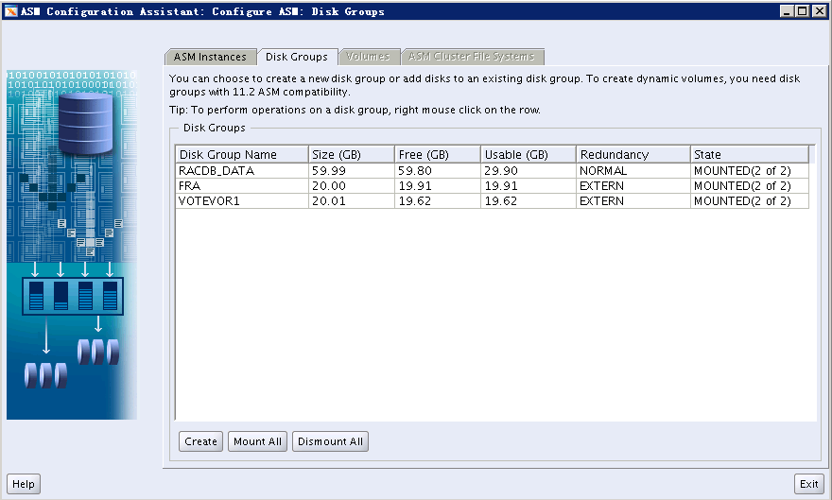

# 六、创建Oracle RAC数据库（DBCA）：

执行DBCA命令创建数据库：

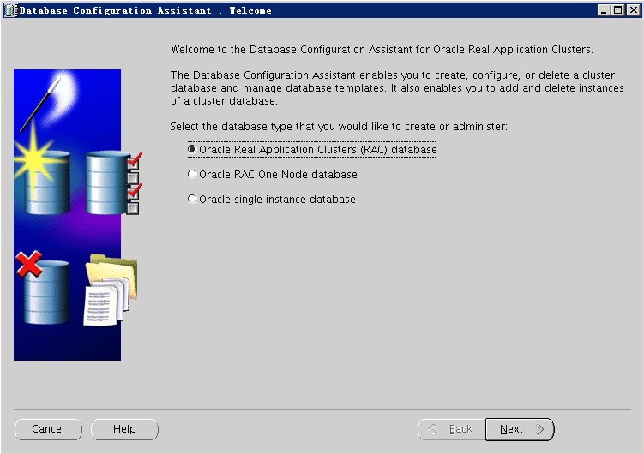

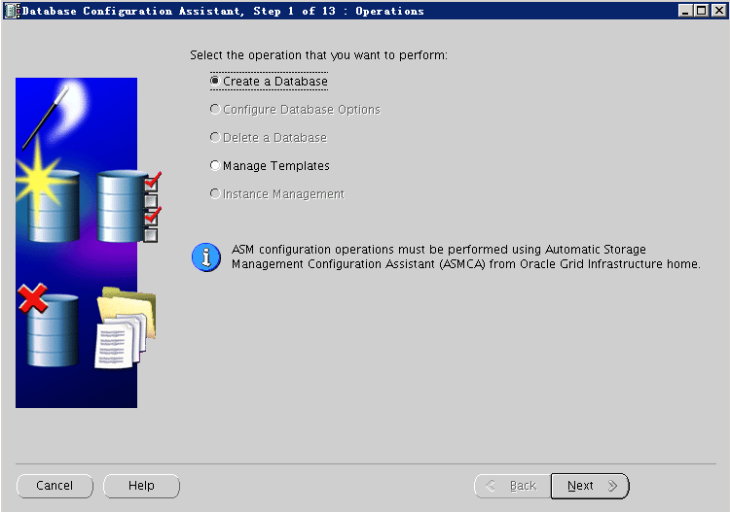

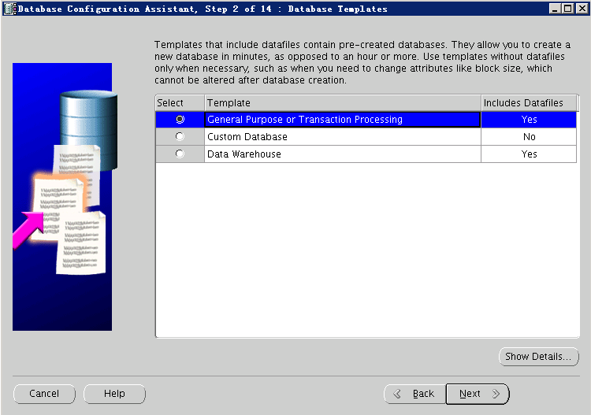

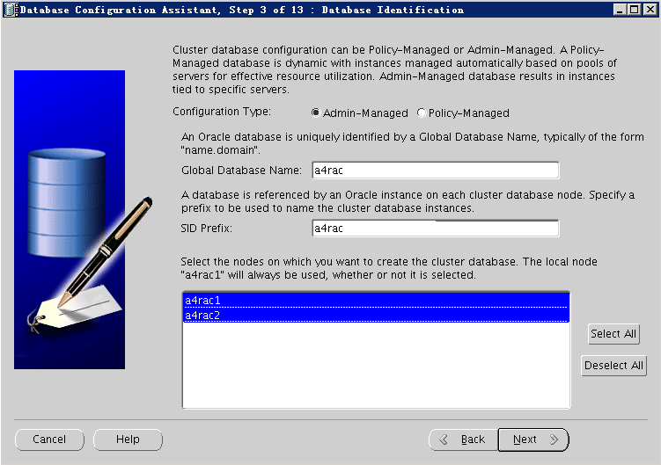

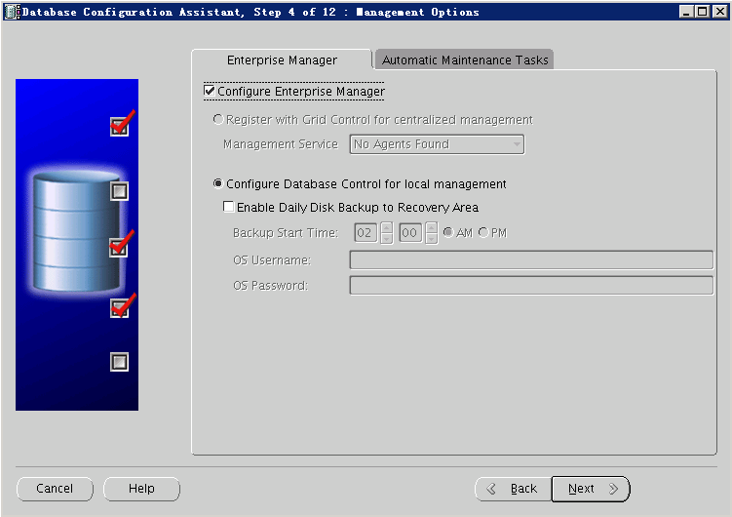

密码为：oracle

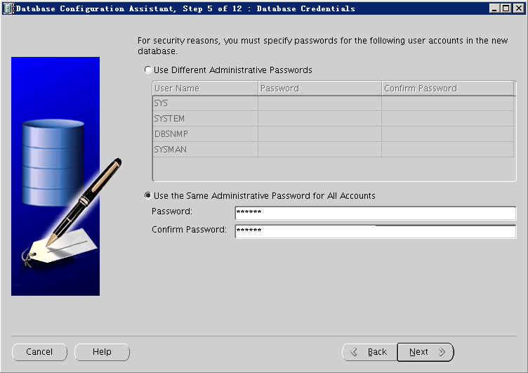

输入asm密码：Oracle_123

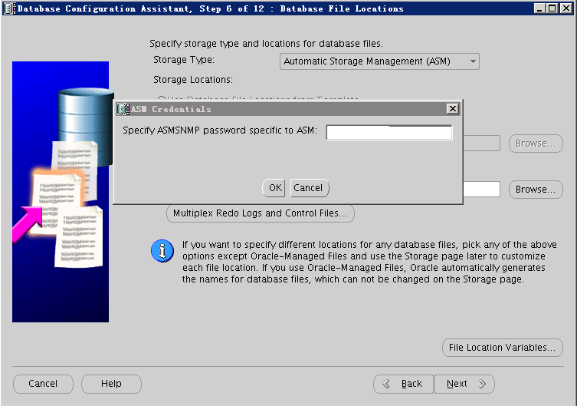

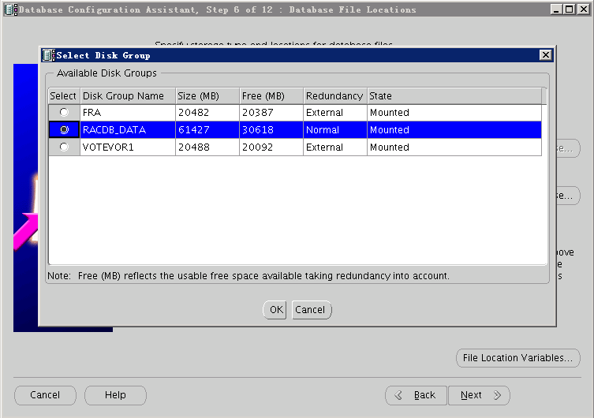

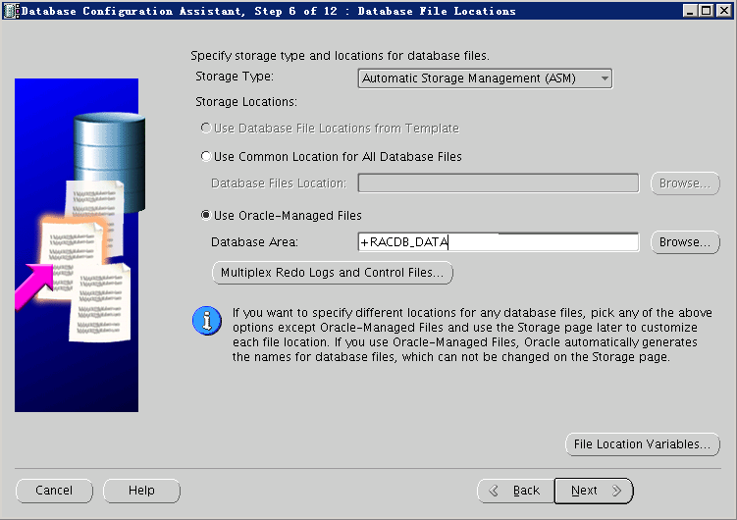

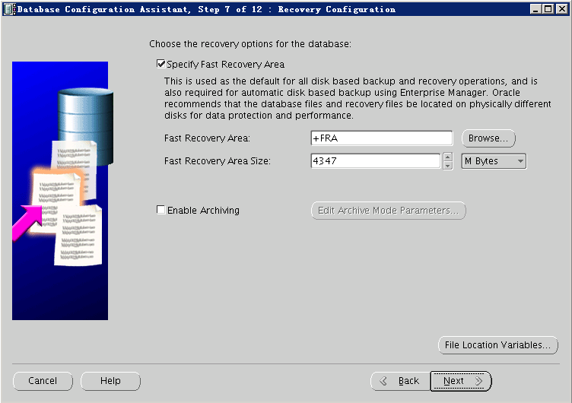

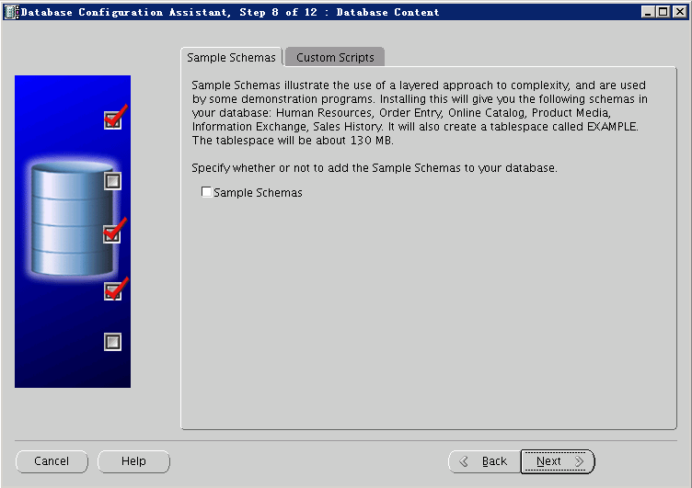

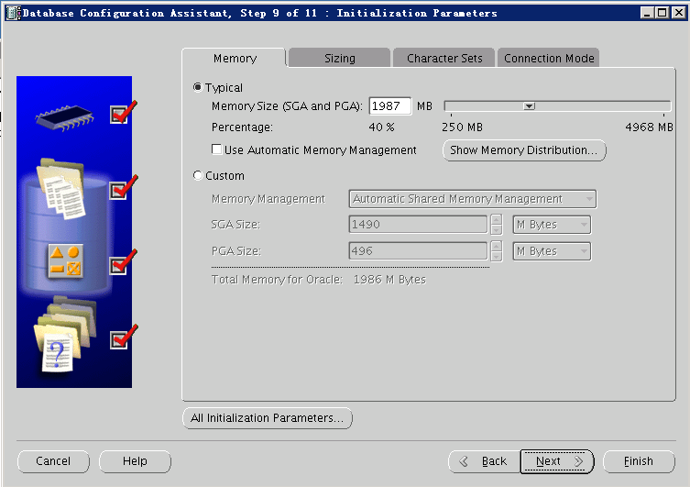

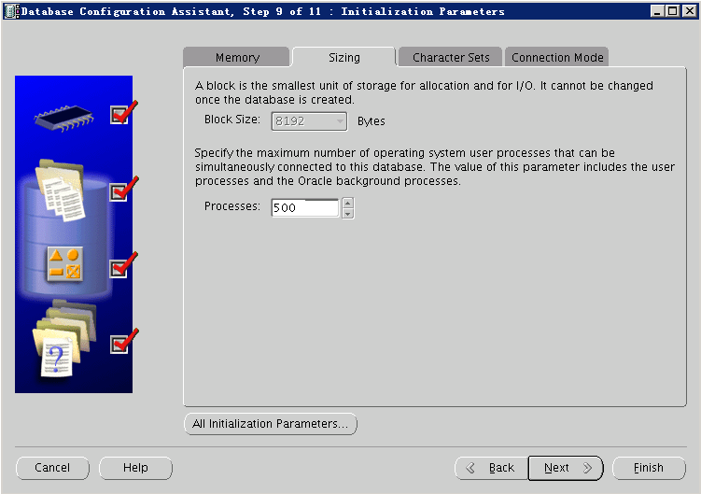

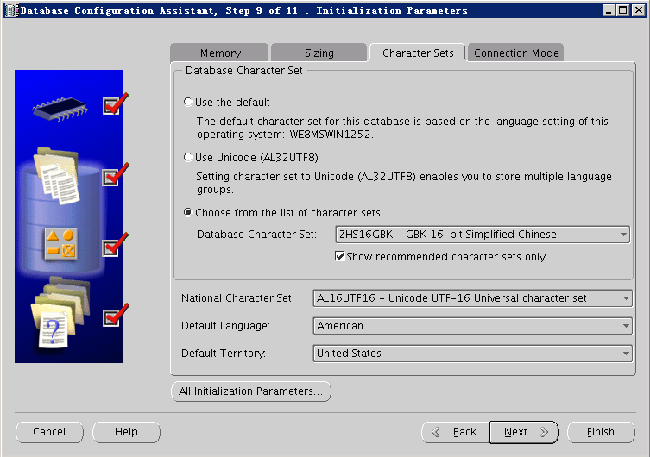

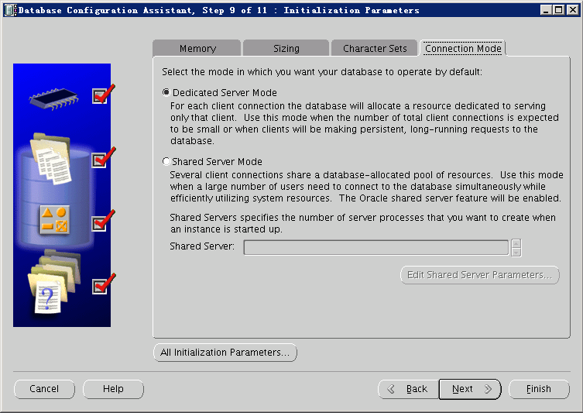

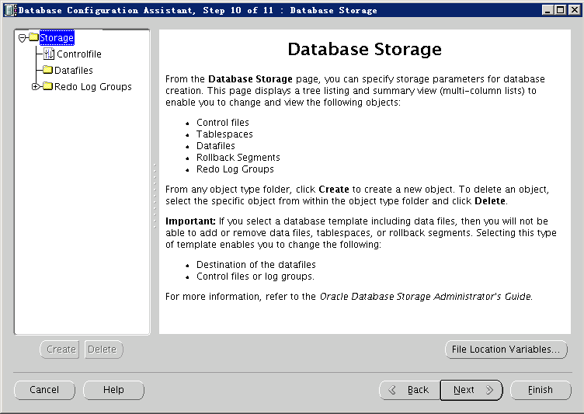

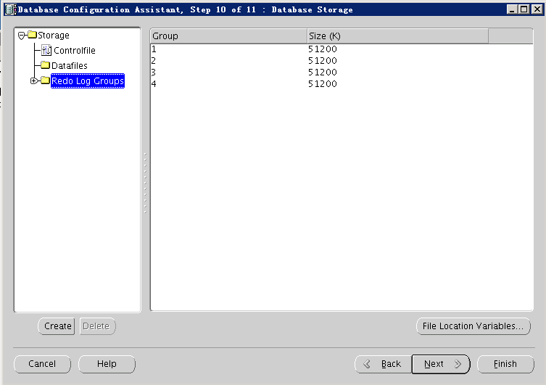

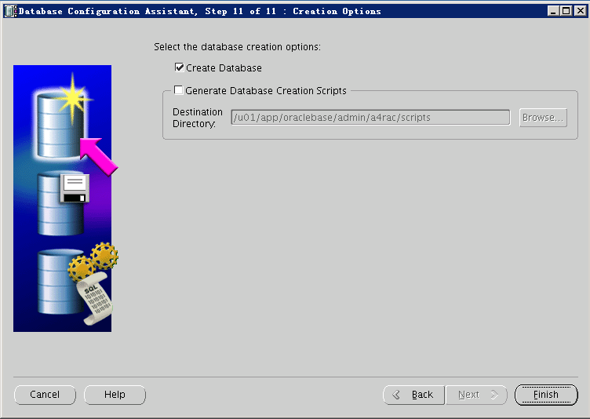

**点击“Finish”:**

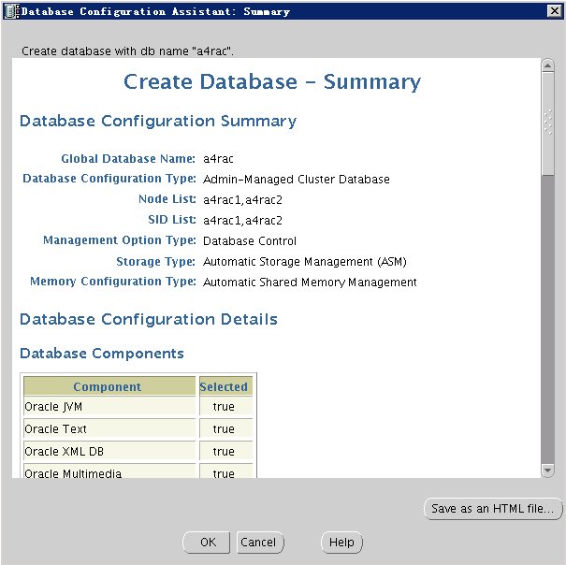

**点击“OK”，开始创建数据库：**

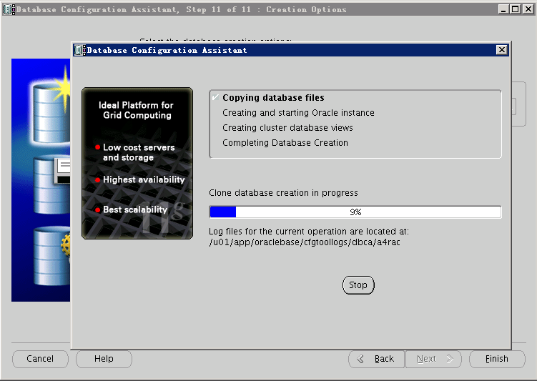

**时间较长，耐心等待，可以喝杯茶或者抽根烟休息会。**

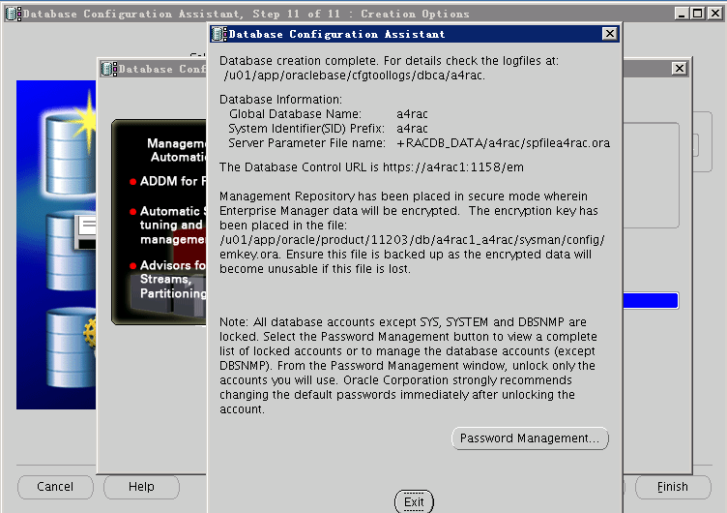

**点击“Exit”退出。**

**执行以下命令查看RAC是否在两个节点上正常运行：**

**所有 Oracle 实例 —（数据库状态）**

**[oracle@a4rac1 database]$** **srvctl status database -d a4rac**

**Instance a4rac1 is running on node a4rac1**

**Instance a4rac2 is running on node a4rac2**

**[oracle@a4rac2 ~]$ srvctl status database -d a4rac**

**Instance a4rac1 is running on node a4rac1**

**Instance a4rac2 is running on node a4rac2**

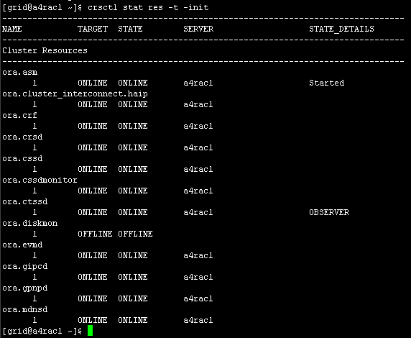

**连接公共实例测试：**

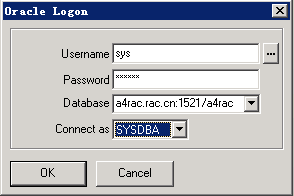

**连接测试成功：**

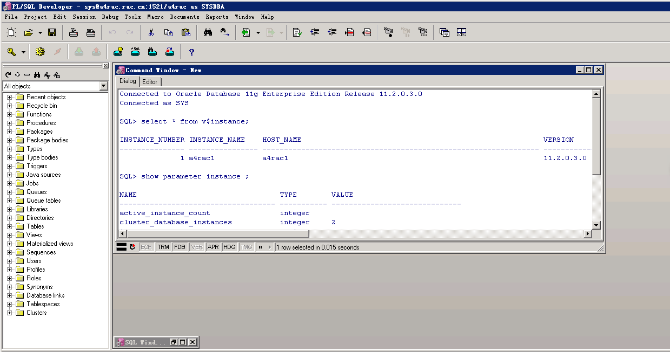

**安装完毕。**

# 八、创建SDE空间数据库表空间：

使用公共实例a4rac连接数据库创建SDE空间数据库表空间(表空间要存放到ASM盘中)：

**SQL> create tablespace SDE**

**2 datafile '+RACDB_DATA' size 1024M**

**3 autoextend on next 20M maxsize unlimited;**

**表空间已创建。**

# 九、使用ArcCatalog工具创建SDE空间数据库：

|  |
| --- |
| 注释：在安装有Desktop10.2服务器上要安装对应的32位Oracle数据库客户端，因为Desktop10.2为32位程序。 |

打开ArcCatalog找到“Create enterprise Geodatabase”工具：

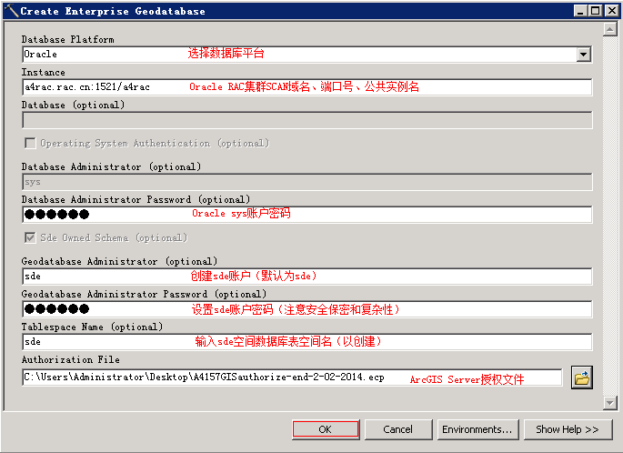

**点击“OK”开始创建sde空间数据库。**

**SDE空间数据库创建成功：**

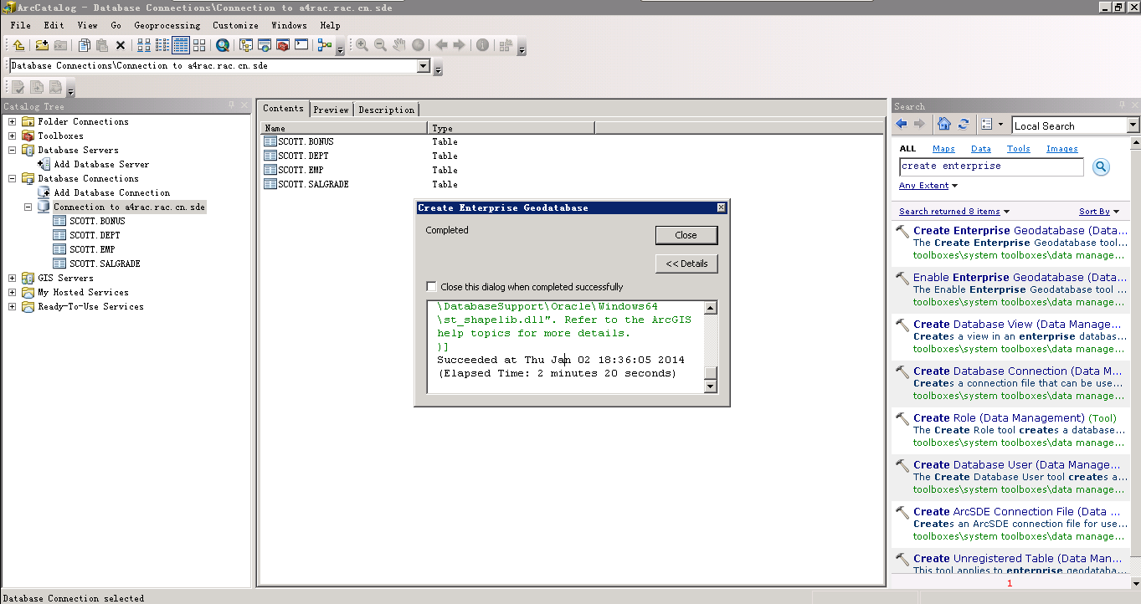

**使用ArcCatalog连接sde空间数据库：**

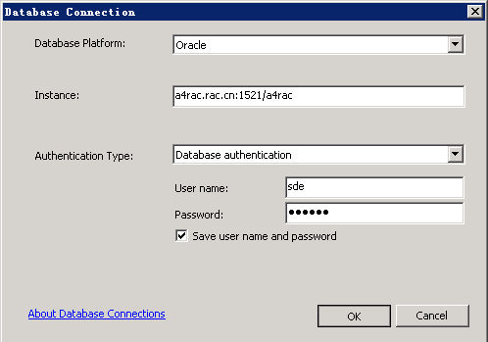

**连接成功：**

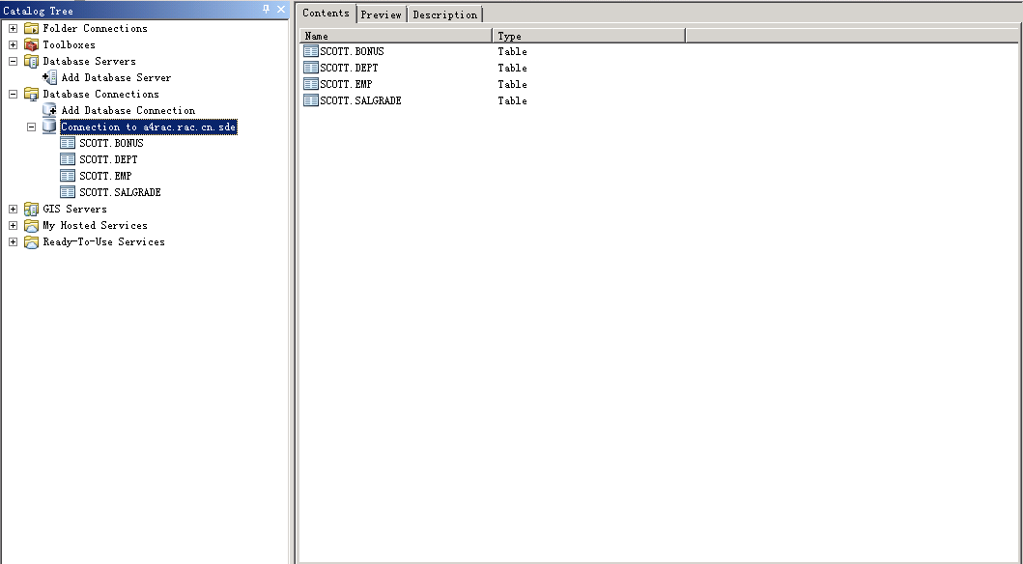

# 十、安装ArcSDE for Oracle11GR2软件：

分别在RAC节点1 和2 上做以下步骤：

## 1.创建sde用户和安装目录：

[root@a4rac1 software]# useradd -d /home/sde -g oinstall -m sde

[root@a4rac1 software]# passwd sde

Changing password for user sde.

New password:

BAD PASSWORD: it is based on a dictionary word

Retype new password:

passwd: all authentication tokens updated successfully.

[root@a4rac1 software]# mkdir -p /oracle/arcsde

[root@a4rac1 software]# chown -R sde:oinstall /oracle/arcsde

[root@a4rac1 software]# chmod -R 777 /oracle/arcsde

## 2.安装ArcSDE软件：

[root@a4rac1 software]# su - sde

[sde@a4rac1 ~]$ cd /mnt/linux/oracle11g_64/

[sde@a4rac1 oracle11g_64]$ ls

01.toc 02.tar b5.nls en.nls install ja.nls jp.nls ko.nls th.nls tw.nls zh.nls

[sde@a4rac1 oracle11g_64]$ ./install –load

ESRI is willing to license the software to you only if you accept and agree to the enclosed license agreement. If you have read and agree with the terms in the enclosed license agreement type 'yes' to continue the installation process, if not press <return> or type 'no' to exit installation process. [no] yes

Press <return> to take the default, '?' for help, '^' to return to

the previous question, or 'q' to quit.

Enter media mount point: [/mediamnt] /mnt/linux/oracle11g_64/

Enter pathname to install directory: [/mnt/linux/oracle11g_64] /oracle/arcsde

ArcSDE version 10.2 for Oracle11g - May 3, 2013

-------------------------------------------------

Choices are:

1 Application Server

2 Command Line Tools

Package numbers to load: [all]

Package selection complete

--------------------------

You have chosen the following packages to be loaded

ArcSDE Product

Application Server

Command Line Tools

Is this correct? [yes] yes

Total size of chosen packages in megabytes: 265.6

Available space in megabytes: 7440.0

List file names while loading? [no]

Loading package(s), Please wait...

Finished loading package(s)

Exiting...

[sde@a4rac1 oracle11g_64]$

## 3.查看安装路径：

[sde@a4rac1 oracle11g_64]$ ls /oracle/arcsde/

Documentation sdeexe102

说明已安装成功！

## 4.修改sde用户环境变量：

[sde@a4rac1 ~]$ vim .bash_profile

export SDEHOME=/oracle/arcsde/sdeexe102

export ORACLE_SID=a4rac1 #该实例名输入本节点实例名a4rac1.

export ORACLE_BASE=/u01/app/oraclebase

export ORACLE_HOME=/u01/app/oracle/product/11203/db

export TNS_ADMIN=$ORACLE_HOME/network/admin

export LD_LIBRARY_PATH=$SDEHOME/lib:/usr/lib:/lib:$ORACLE_HOME/lib

export PATH=$PATH:$HOME/bin:$SDEHOME/bin:$ORACLE_HOME/bin

**加载变量配置文件：**

[sde@a4rac1 ~]$ source .bash_profile

**修改sde服务配置文件：**

Su – sde

[sde@a4rac1 ~]$ vim /oracle/arcsde/sdeexe102/etc/services.sde

**执行以下操作之一来定义 ArcSDE 服务接受连接请求时所使用的服务名称和 TCP/IP 端口号：**

**1.删除默认条目 esri_sde 5151/tcp 中的注释标记 (#)。**

**2.或者添加唯一服务名称和 TCP/IP 端口号，例如 arcsde 4000/tcp。**

Su – root

[root@a4rac1 software]# vim /etc/services //修改操作系统服务文件在最后一行添加

esri_sde 5151/tcp #ArcSDE for Oracle11G RAC

**启动sde服务：**

[sde@a4rac1 ~]$ sdemon -o start

**输入sde账户密码：（sde12#）**

**查看sde服务状态：**

[sde@a4rac1 ~]$ sdemon -o status

ArcSDE Instance esri_sde Status on a4rac1 at Wed Jan 8 01:57:09 2014

-------------------------------------------------------------------------

Server Connection Mode: Accepting Connections

Active Server Processes: 1

**分别在节点1、2上配置oracle extproc以实用SQL访问地理数据库：**

vi $ORACLE_HOME/hs/admin/extporc.ora

SET EXTPROC_DLLS=ONLY: /oracle/arcsde/sdeexe102/lib/libst_shapelib.so

**替换库文件位置：**

**使用sde用户通过公共实例a4rac连接Oracle数据库：**

select * from user_libraries;

**更新替换库文件：**

CREATE OR REPLACE LIBRARY st_shapelib AS

'/oracle/arcsde/sdeexe101/lib/libst_shapelib.so';

**查询是否更新成功：**

select * from user_libraries;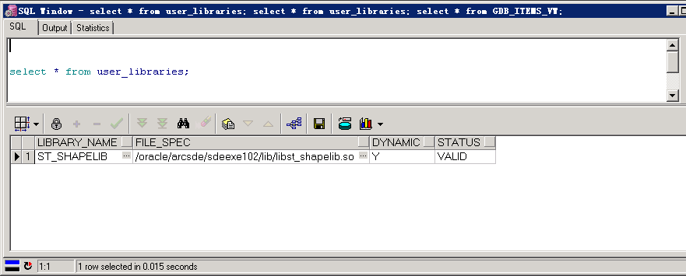

**重新编译：**

**alter package sde.st_geometry_shapelib_pkg compile reuse settings;**

**查看是否替换更新成功：（如果下面的sql语句查询失败可推出数据库连接工具如：PL/SQL Developer或者重启数据库再查看，shutdown immediate； startup；）**

**select * from GDB_ITEMS_VW;**

**成功查询界面如下：**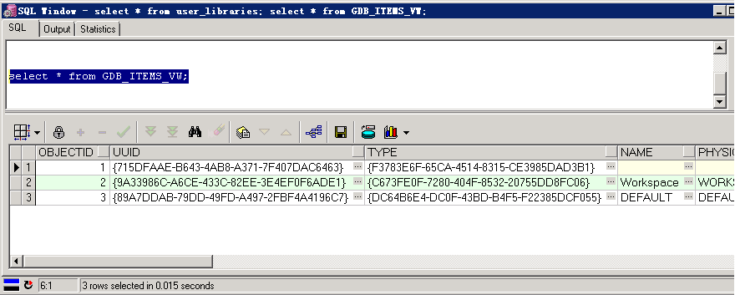

**ArcSDE for Oracle11G安装配置启动完成。**